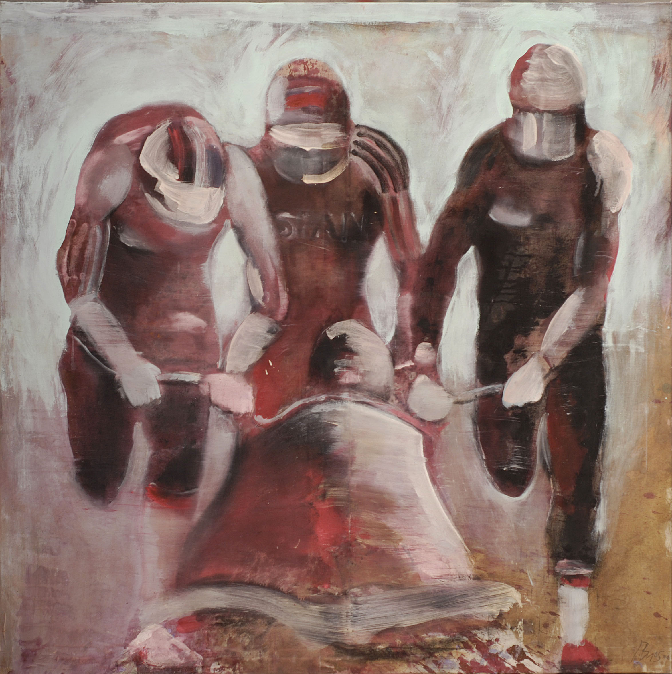
Moscow City Government
Moscow City Department of Culture
Russian Academy of Arts
Embassy of the Kingdom of Spain in Moscow
Moscow Museum of Modern Art

present

Ignacio Burgos
Retrospectiva 1993-2011

Opening: November 8, 2011, at 7 pm
Dates: November 9 – December 14, 2011
Venue: Moscow Museum of Modern Art, Tverskoy blvd, 9

The exhibition is held within Russia-Spain Year 2011

Moscow Museum of Modern Art continues the program of the Year of Spain in Russia with the solo exhibition of Ignacio Burgos, one of the most interesting contemporary artists in his country. His art is recognizable and self-contained; for long years, the master is faithful to his style and does not surrender to the dictation of markets, galleries, and curators. His manner can be defined as ‘figurative expressionism’: in his canvases, the exquisite palette of blues, purples and ochres comes into balance with a special Mediterranean light, and soft but precise brushwork.
During his career, Ignacio Burgos travelled a lot and lived in different cities, from Barcelona and New York to Shanghai and Casablanca. These migrations brought a variety of themes and subjects to his oeuvre: here one can find Arabic and Chinese women, soldiers of Egyptian army, participants of a yacht race, children on the seashore, etc. These pictures have nothing heroic or dramatic in them, these stories are about real life, about how people act in simple everyday situations. However, works by Ignacio Burgos contain something timeless and universal, something that remounts to the heritage of Spanish classics, such as Goya, Velasquez, or Ribera.
Ignacio Burgos is well known to the international audience: his personal exhibitions are shown in major world capitals, and his works are kept in museums and private collections around the world. Apart from painting, the artist has worked with photography and metal, and created glass sculptures. The exhibition at the Moscow Museum of Modern Art familiarizes the Russian public with Ignacio Burgos’s painted works, represented in their full diversity.

