Women's Movement's FEMEN Public Appeal
Dedicated to the Independence Day of Ukraine

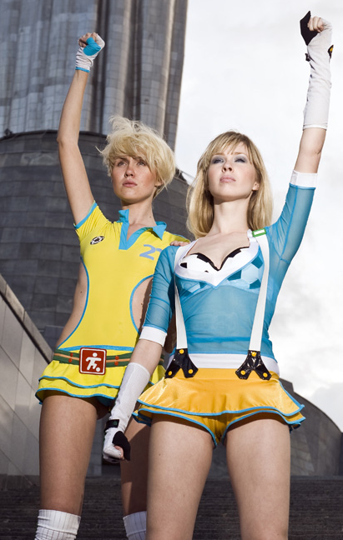
The Women's Movement FEMEN calls upon Ukrainian and International community to boycott the official celebrations of 18th Anniversary of Independence of Ukraine.
On the eve of the annual official celebrations dedicated to the Independence Day FEMEN declares: we have nothing to celebrate, we have no moral right to celebrate the day of the state which for 18 years of it's existence has become the state of permissiveness for the caste of the «chosen ones», the state where the rest are unprotected and have no rights, the state which is not able to fulfil its' main function – to protect its' citizen and provide proper conditions for their living and prosperity.

Our declaration is based on the great numbers of our compatriots who live in sexual slavery and the fact that the state has no desire to take any immediate actions to solve the problem.

To our national shame Ukraine is becoming a brothel-country, the main supplier of «living goods» for the world slavery markets. It is enough to notice that according to the international experts figures ¾ of prostitutes in Europe are Ukrainian Women! Daily thousands of Ukrainian women are exposed to violence with impunity in the most awful manner. It means not only thousands of raped fates but also maligned image of our country in the eyes of the world community.

In the situation that exists we consider official pompous celebrations with parades and fireworks unacceptable.

We hope for your understanding and support of our position.

If the war is not over till the last soldier is buried, the independence is not achieved till the state is not able to protect its every citizen.

Anna Hutsol
FEMEN Women's Movement Leader

